**NOTE** I did not edit any of the code that I cloned from the github ClientSocket repository. I ran the code as is.

-Gideon

1:30pm 12/8/2018

Steps 1-27 set up the game. Skip to step 28 to see the problem.

Issue 1:

**Prompt for first player to make his/her move does not show up when player 6 clicks start game first.**

Steps to reproduce issue:

1. Open IDE (I used Eclipse Java 2018-09). I used only one workspace for this test.
2. Run MasterServer.java. See picture below for output:

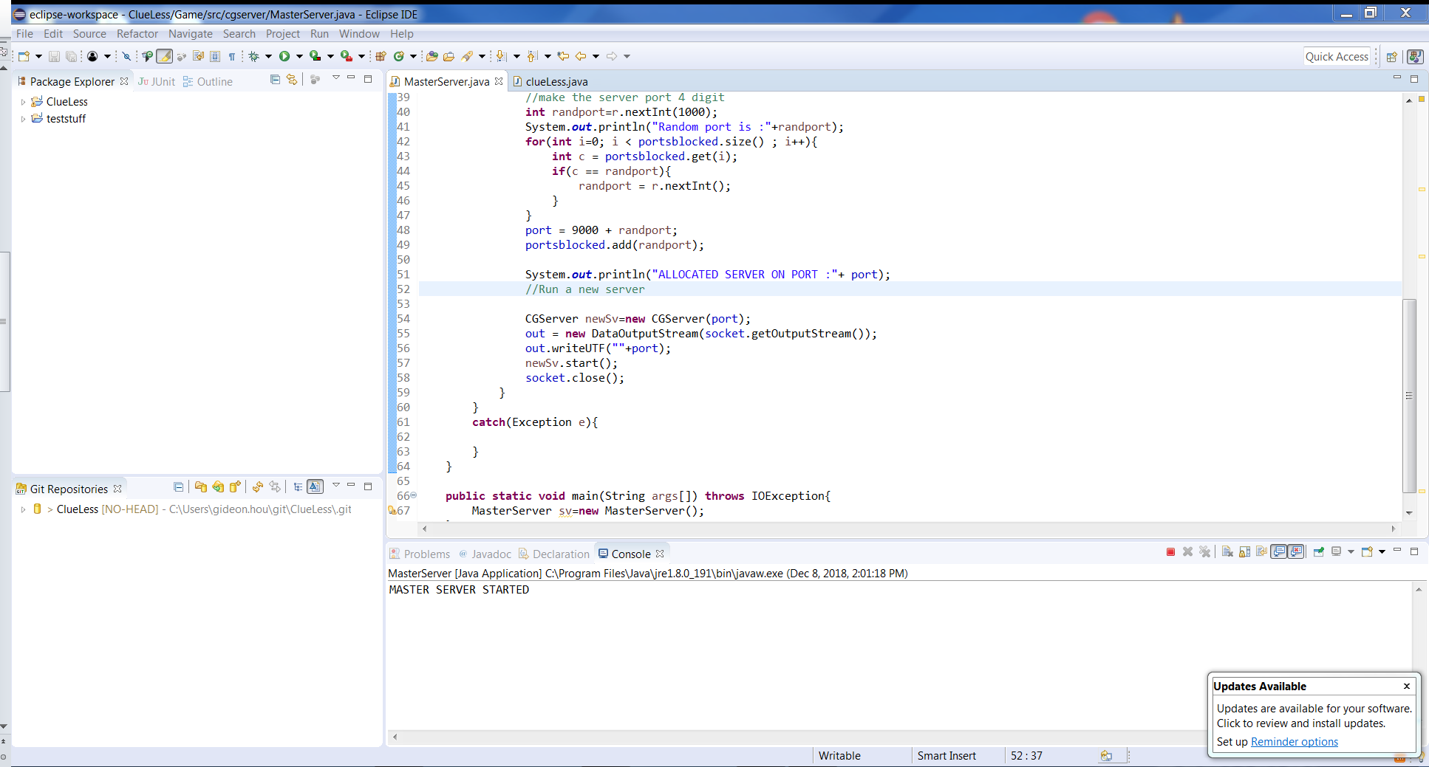

1. Run clueLess.java in the same IDE.
   1. Welcome screen pops up. See picture below

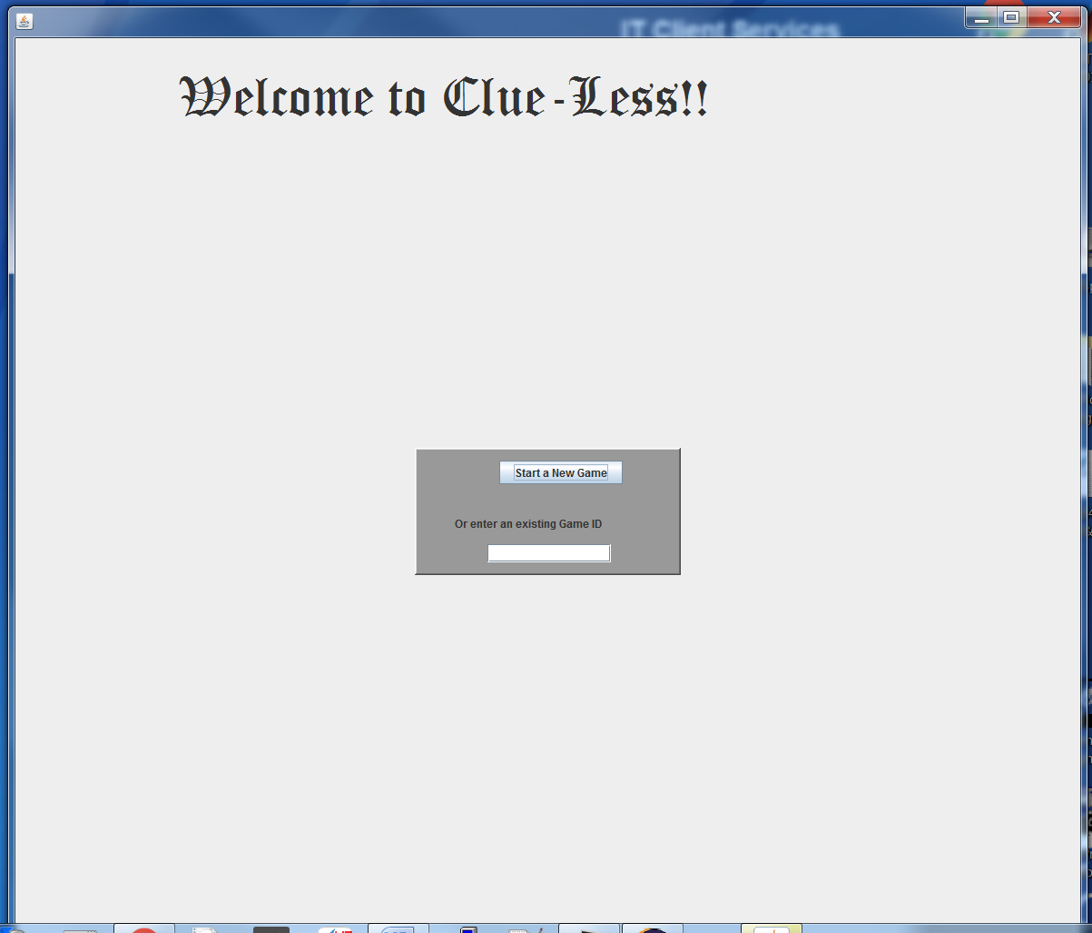

1. Click “Start a New Game”
   1. My Game ID was 9977
2. Click “Ok”
3. Enter “f0” for my name then hit the enter key.
   1. Console for first instance of clueless.java gets updated. Note that I took the following screen shot after player “f1” was added. See below:

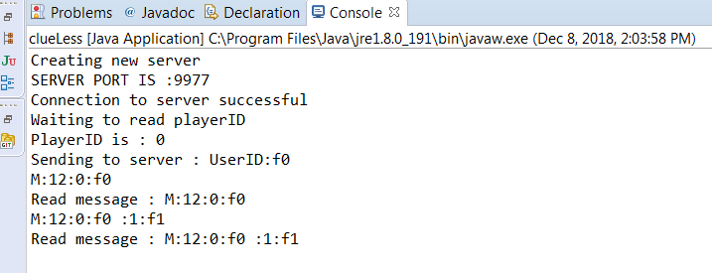

1. Lobby screen pops up. Eclipse console for instance of MasterServer.java gets updated. See below:

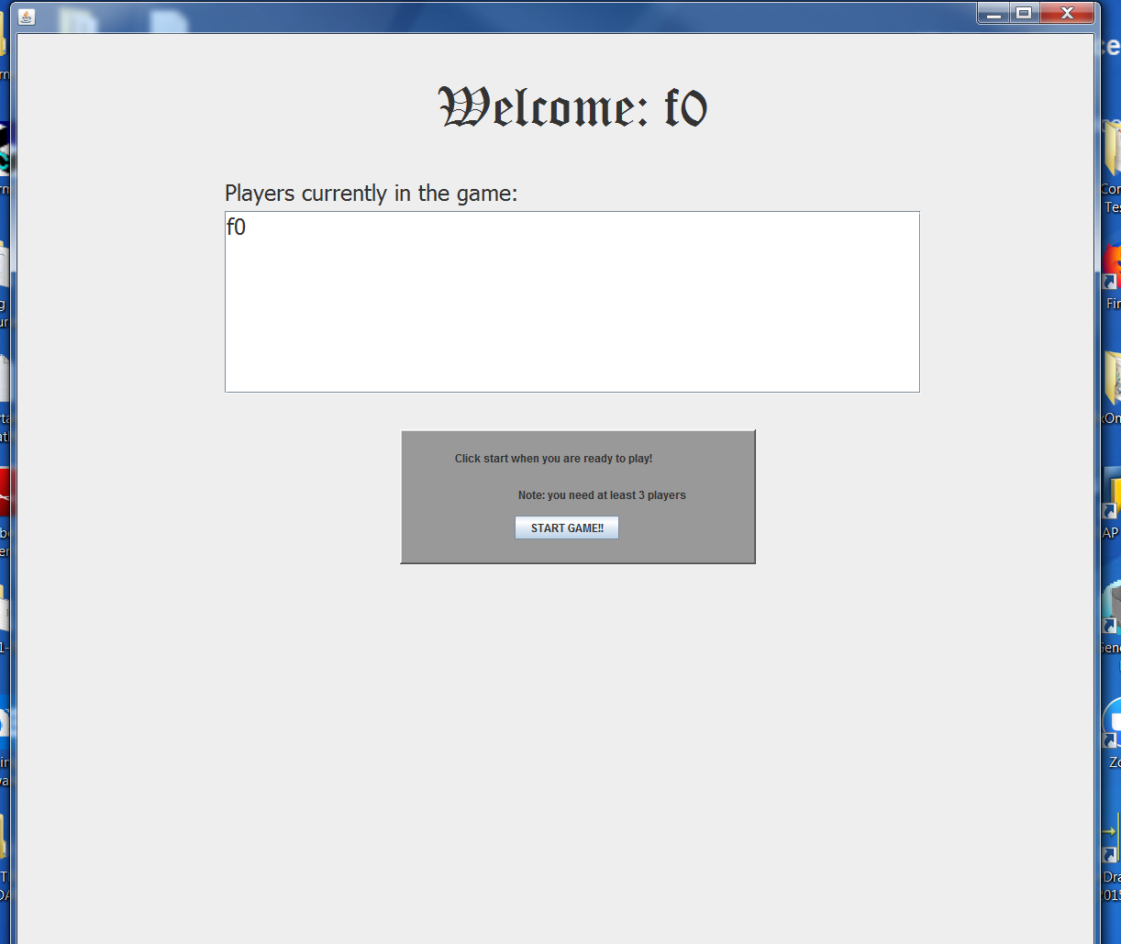

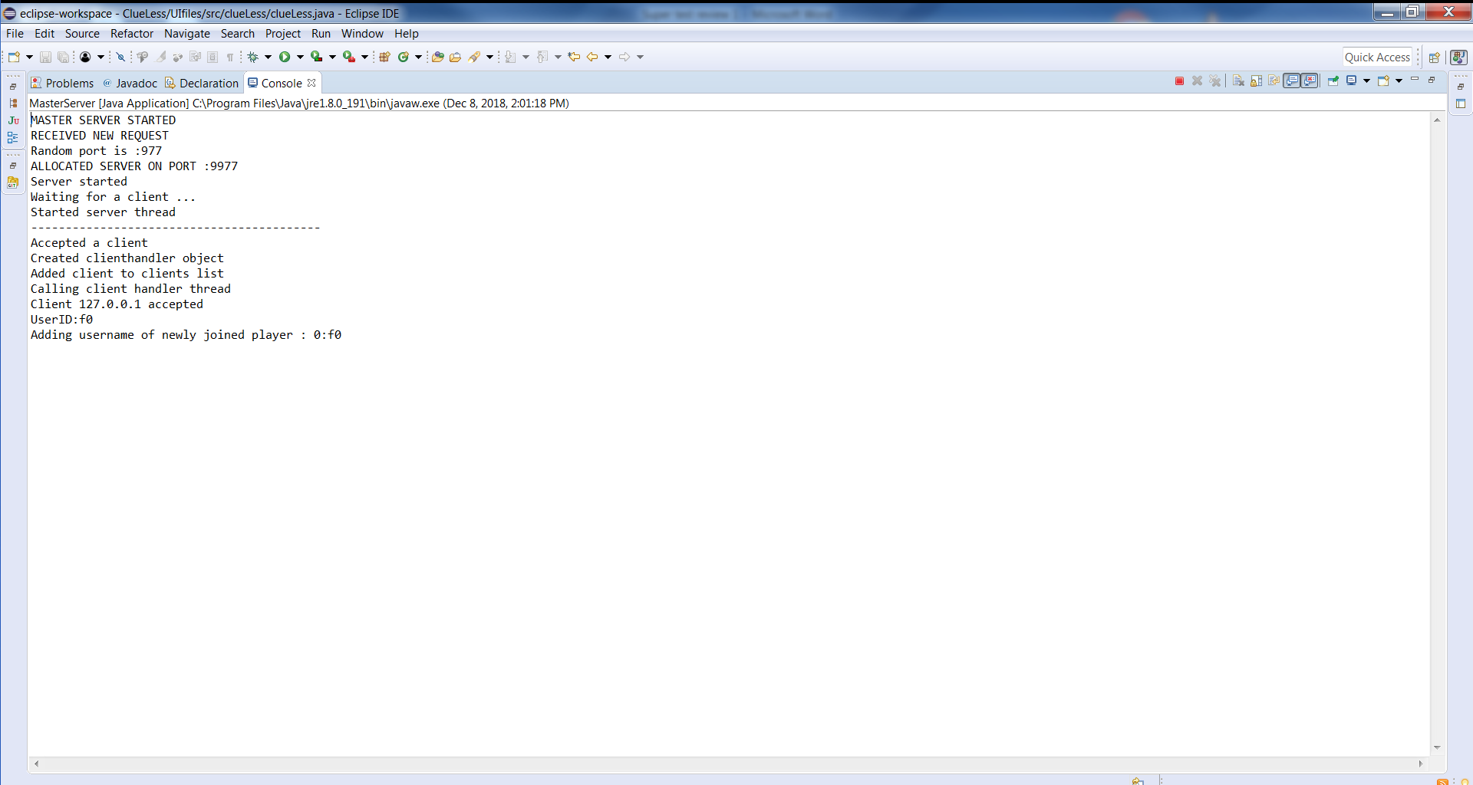

1. Run clueLess.java again in the same IDE.
   1. Welcome screen pops up
2. Enter Game ID 9977
3. Enter player name “f1”. Hit Enter
   1. Console for this instance of clueLess.java gets updated. See below

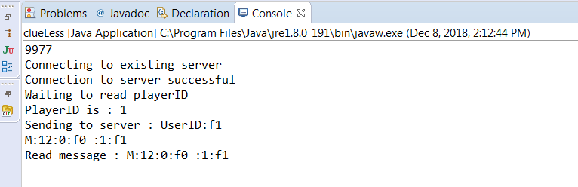

1. Lobby screen pops up for player “f1”. Lobby screen for previous players get updated as well. Eclipse console for instance of MasterServer.java gets updated. See below:

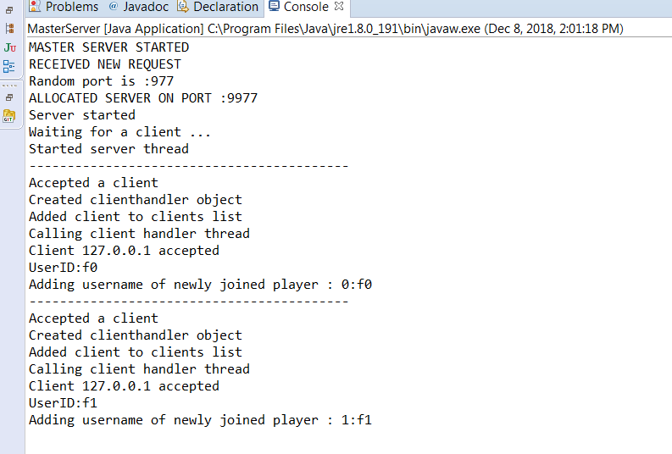

1. Run clueless.java again in the same IDE.
   1. Welcome screen pops up
2. Enter Game ID 9977
3. Enter player name “f2”. Hit Enter
   1. Console for this instance of clueless.java gets updated. See below:

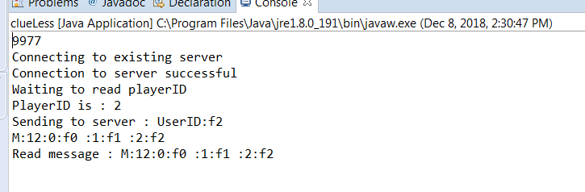

1. Lobby screen pops up for player “f2”. Lobby screens for previous players get updated as well. Eclipse console for instance of MasterServer.java gets updated. See below:

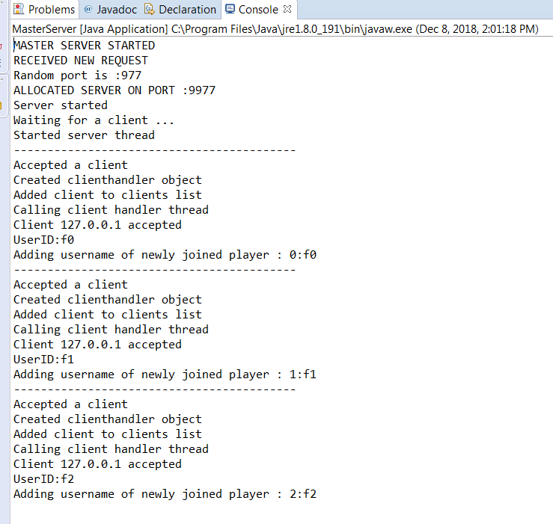

1. Run clueless.java again in the same IDE.
   1. Welcome screen pops up
2. Enter Game ID 9977
3. Enter player name “f3”. Hit Enter
   1. Console for this instance of clueless.java gets updated. See below:

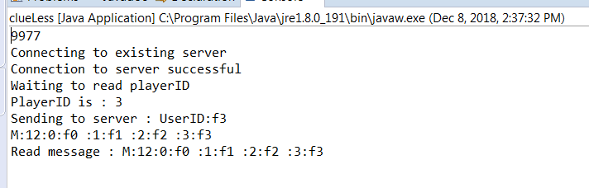

1. Lobby screen pops up for player “f3”. Lobby screens for previous players get updated as well. Eclipse console for instance of MasterServer.java gets updated. See below:

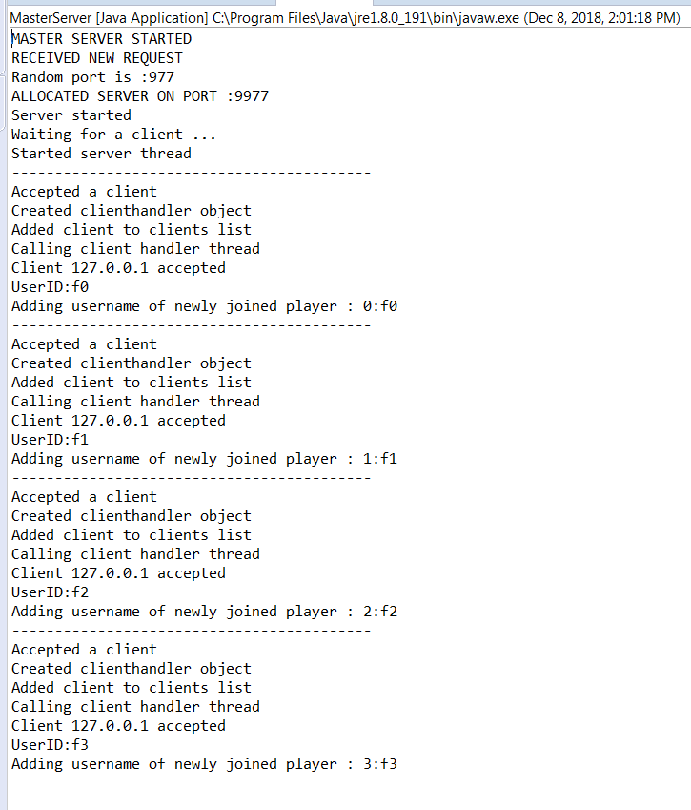

1. Run clueless.java again in the same IDE.
   1. Welcome screen pops up
2. Enter Game ID 9977
3. Enter player name “f4”. Hit Enter
   1. Console for this instance of clueless.java gets updated. See below:

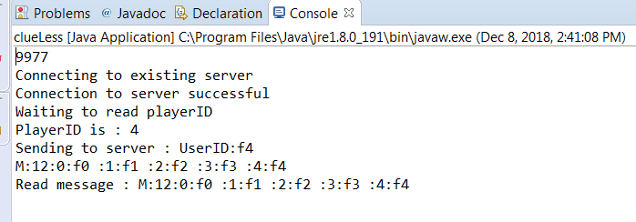

1. Lobby screen pops up for player “f4”. Lobby screens for previous players get updated as well. Eclipse console for instance of MasterServer.java gets updated. See below:

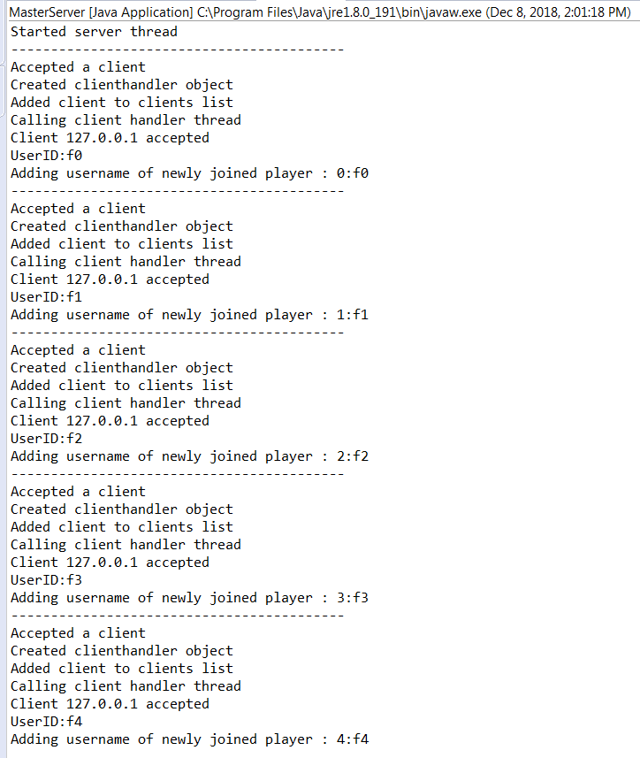

1. Run clueless.java again in the same IDE.
   1. Welcome screen pops up
2. Enter Game ID 9977
3. Enter player name “f5”. Hit Enter
   1. Console for this instance of clueless.java gets updated. See below:

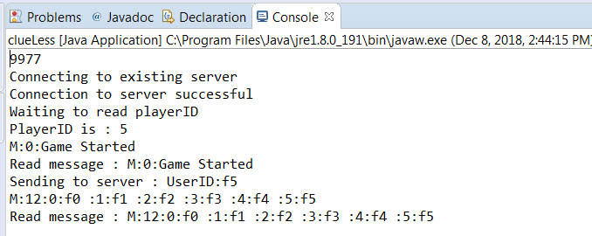

1. Lobby screen pops up for player “f5”. Lobby screens for previous players get updated as well. Eclipse console for instance of MasterServer.java gets updated. See below:

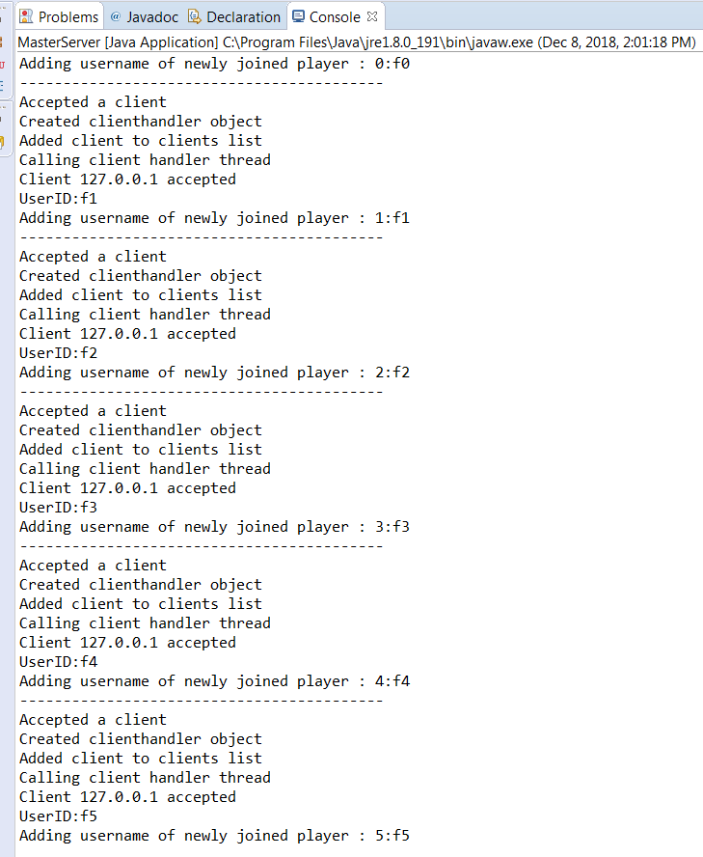

1. Click “START GAME!!” for player “f5”’s lobby screen
   1. Only player “f5”’s window gets updated to the game board, the rest of the players’ lobby screen do not get updated. See below:

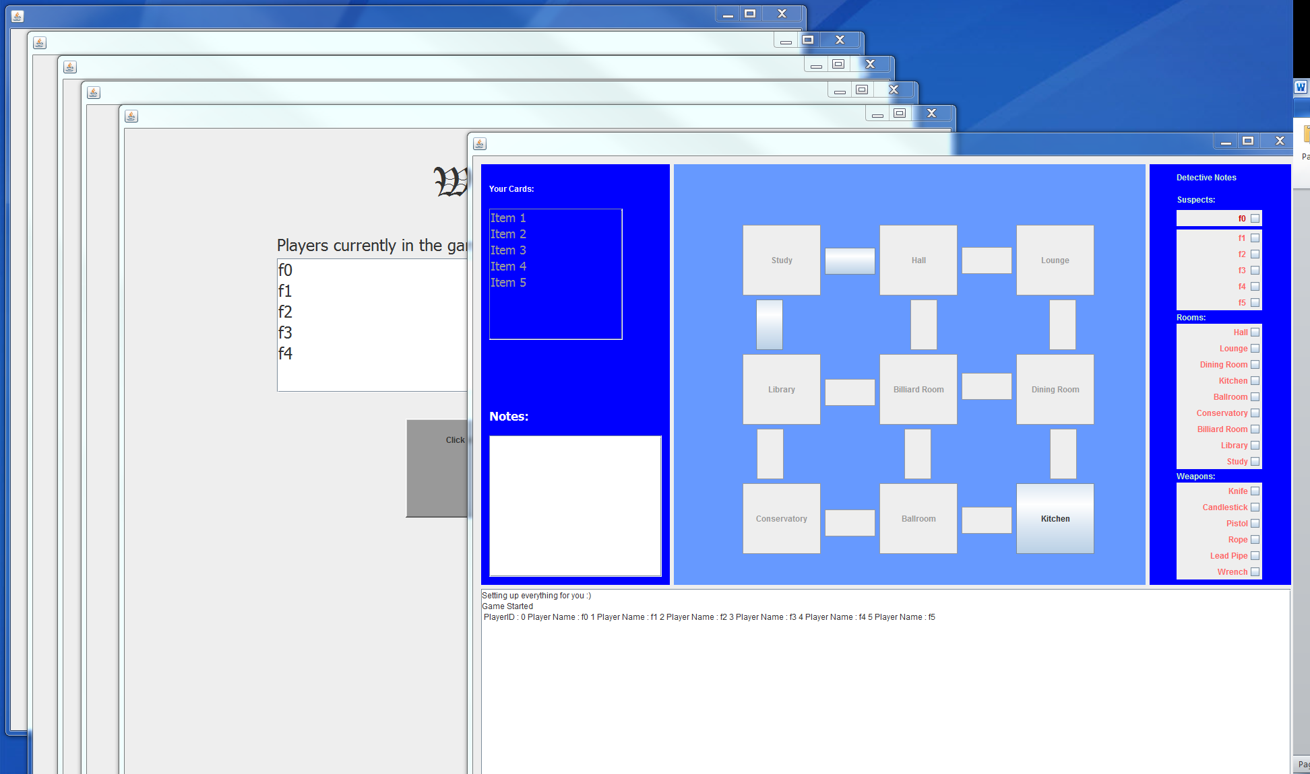

1. Console for every player except “f5” and “f5” threw an array out of bounds exception. See below:
   1. “f0”:

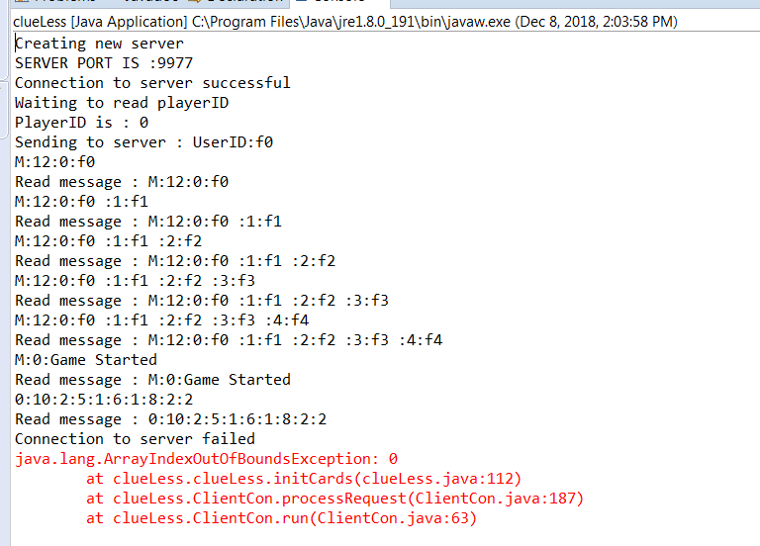

* 1. “f1”:

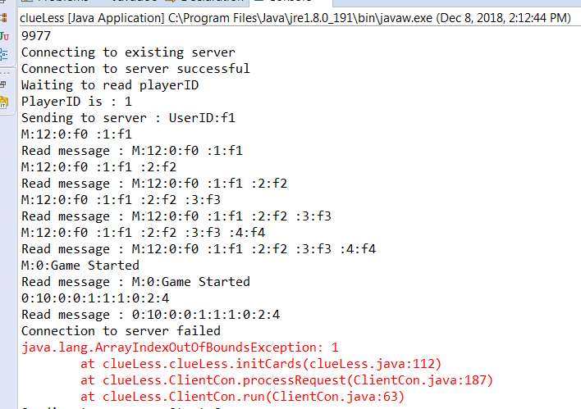

* 1. “f2”:

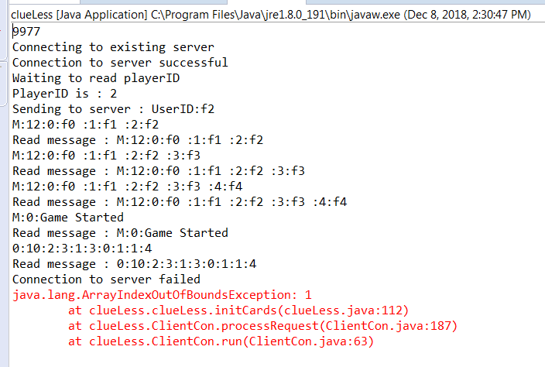

* 1. “f3”: (no failure)

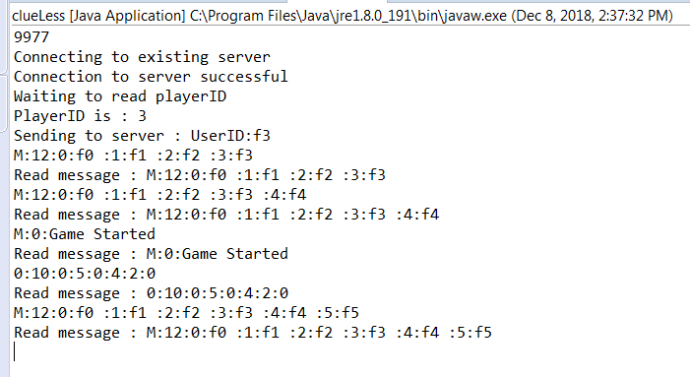

* 1. “f4”:

